**The “’Don’t Get Stranded’ Strategy Game” Game Strategy**

*By Aaron Sykes and Logan O’Quinn*

Our agent’s starting strategy is to attempt to move towards the middle of the board while trying to prevent the opponent from doing the same. Moving towards the middle serves the purpose of giving our player the most opportunity for moves on the next and subsequent turns, as there is more space in the middle of the board than along the sides. Conversely, forcing our opponent to move away from the midele greatly limits the amount of potential moves early on in the game. One idea behind this strategy is that using the sides of the board to limit our opponent’s moves is more effective than merely pushing out individual tiles. While along the side, for example, a player only has a maximum of 5 potential moves, whereas a player in the middle of the board has up to 8 moves. A player in the corner squares is at an even larger disadvantage, having only 3 potential moves, with 2 of those resulting in being along a side.

The agent will attempt to force the opponent into the corner by pushing out pieces that are between the opponent and the middle areas of the board, preferably 1 to 3 moves ahead of where the opponent is currently located. Using any more moves ahead could potentially result in a search space that is too large for our agent to handle and too much variation in the opponent’s potential moves. Since it is likely that the opponent will be attempting to maximize their own number of moves, our agent can remove tiles near the middle to discourage the opponent from moving towards the middle of the board and instead cause them to go closer to the corners. Since our agent weighs moving towards the middle along with the number of moves it will have, we believe that it is less susceptible to a similar strategy used by an opponent.

In the late game, our agent will begin to prioritize maximization of its own potential moves over solely moving towards the middle of the board. The purpose of this is to adopt a more defensive strategy after an opponent has been caught in a smaller region or is relegated to the corner areas of the board. Our agent will remove the tiles that would result in the quickest isolation case for the opponent, using the minimax algorithm with alpha-beta pruning in order to choose the best move to make in a given scenario.

Our agent will switch from our early strategy to our late minimax strategy when there are less than 15 tiles remaining on the board that can be punched out. The heuristic for our early game strategy is used to determine both where our agent should move and which tile it should push out that would limit the opponent the most. To determine the most beneficial move in the early game, we look at all of the neighbors from our current location and determine how many possible moves are available for each neighbor and then we subtract the number of our opponent’s moves and then also subtract the distance to the closest middle square on the board. We use the move with the highest value. To determine which tile to pop out, we apply the same heuristic to our opponent’s location and pop out the tile with the highest value that the evaluation returns.

The heuristic for our minimax evaluation is the number of moves available to our agent less the number of moves available to the opponent. We find this information using the methods built into the Board class.

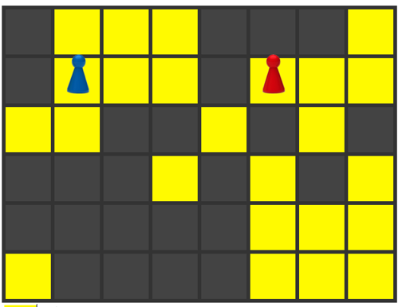

With the above board configuration and our agent controlling both players, the red player would move down and to the right in order to maximize its potential moves. While the early strategy tries to minimize the distance to the middle, creating more moves for itself will be prioritized over moving towards the middle. The red player will punch out the square immediately to the right of the blue token in order to prevent the blue player from moving to a space that would give it the most amount of moves. On the blue player’s turn, our agent will move up and to the right to get the maximum number of available moves, and it will push out the piece at location 29 (circled) on the board to force the red player towards the side.